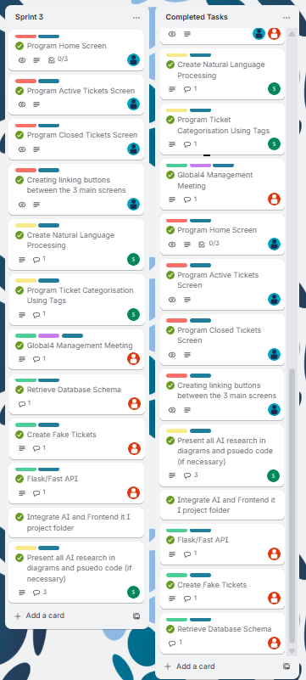
Trello Snapshots from Sprint 3 and Completed Deck

